# Power Automate workflow

Request of time-off Power Automate workflow guide

Microsoft, July 2020

Microsoft may have patents, patent applications, trademarks, copyrights, or other intellectual property rights covering subject matter in this document. Except as expressly provided in written license agreement from Microsoft, the furnishing of this document does not give you any license to these patents, trademarks, copyrights, or other intellectual property.

Complying with all applicable copyright laws is the responsibility of the user. Without limiting the rights under copyright, no part of this document may be reproduced, stored in or introduced into a retrieval system, or transmitted in any form or by any means (electronic, mechanical, photocopying, recording, or otherwise), or for any purpose, without the express written permission of Microsoft Corporation.

For more information, see Use of Microsoft Copyrighted content at <http://www.microsoft.com/about/legal/permissions/>

Microsoft®, Edge®, and Windows® are either registered trademarks or trademarks of Microsoft Corporation in the United States and/or other countries. Other Microsoft products mentioned herein may be either registered trademarks or trademarks of Microsoft Corporation in the United States and/or other countries. All other trademarks are property of their respective owners.

Contents

[Power Automate workflow 0](https://microsoft-my.sharepoint.com/personal/matrs_microsoft_com/Documents/MIP/Hackathon/Deploy%20PowerAutomate%20Workflow.docx#_Toc46499253)

Intro 3

Prerequisites 3

Power Automate Sample 3

Diagram 3

Connectors 4

Power Automate Flow deployment 6

Import Package 6

Customize Power Automate flow 11

# Intro

This document is intended to explain the Power Automate portion of this hackathon and guide the attendee in importing the Power Automate sample provided along with the workshop.

# Prerequisites

Because, the existing SharePoint list “Time off requests” already has a SharePoint 2010 Workflow activated, let us now create a new List called “Time off requests – New” to which the Power Automate flow will be bound to. To create the new list, login to the demo site collection, for example, https://<tenantname>.sharepoint.com/sites/contosoelectronics1 -> Site Contents -> New -> List ( see image below).

On the subsequent screen, select “From an existing list” on the left hand pane -> give the name to the new list as “Time Off Requests – New” and select the existing “Time Off Requests” list (see image below).

You should now see the new list on the left-hand navigation.

# Power Automate Sample

The power automate sample provided is meant to replace the SharePoint 2010 workflow deployed in the test tenant. Following, a description of the connectors used and the reasons behind.

## Diagram



## Connectors

#### SharePoint connector

* **Trigger**:

Power Automate workflow will be triggered when a new item is created or modified.

This way we will take action whether the person is creating a new time off request or asking a modification over an existing request.

**Actions**:

Once the request is approved, the SharePoint connector is utilized to create, modify, or cancel an event in the Site’s Calendar depending on “Request Status”.

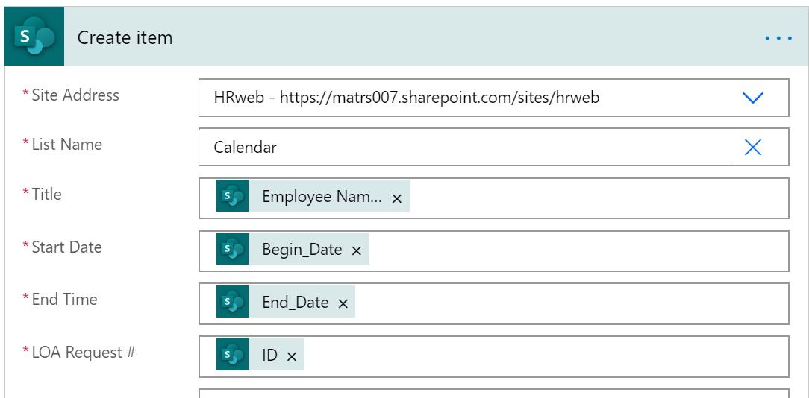



#### Microsoft 365 Users

This connector is used to get the manager of the user that created or modified the item in SharePoint and use in the approvals and notifications.

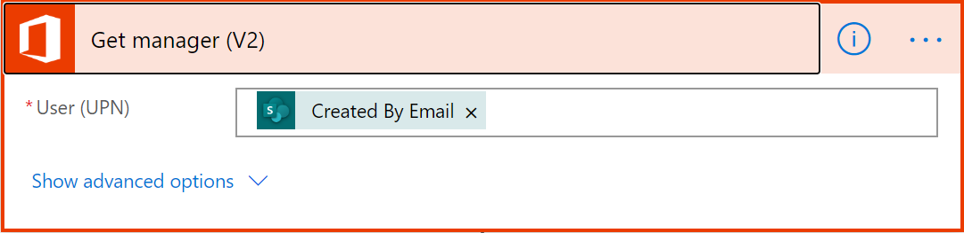

#### Outlook connector

The Outlook connector is used to notify the different stakeholders of the various states of the Time Off requests.

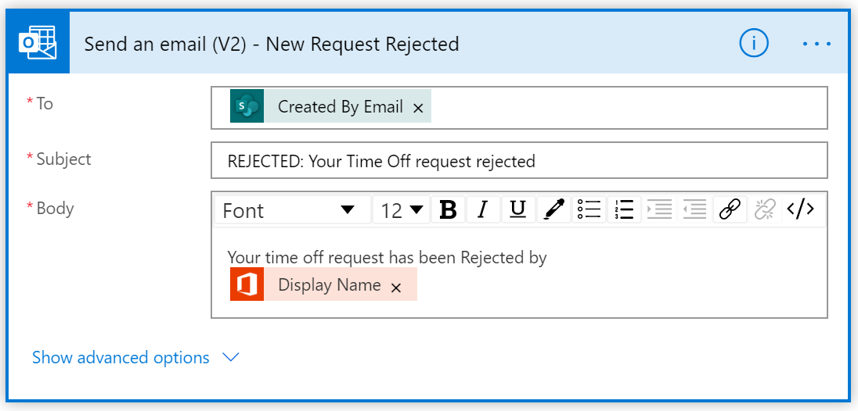

#### Approvals Connector

With this connector we will start an approval process, send the request to the Manager, and wait for the manager to respond. Once Power Automate captures the response from the manager, it will use a condition control to direct the flow to the next step.

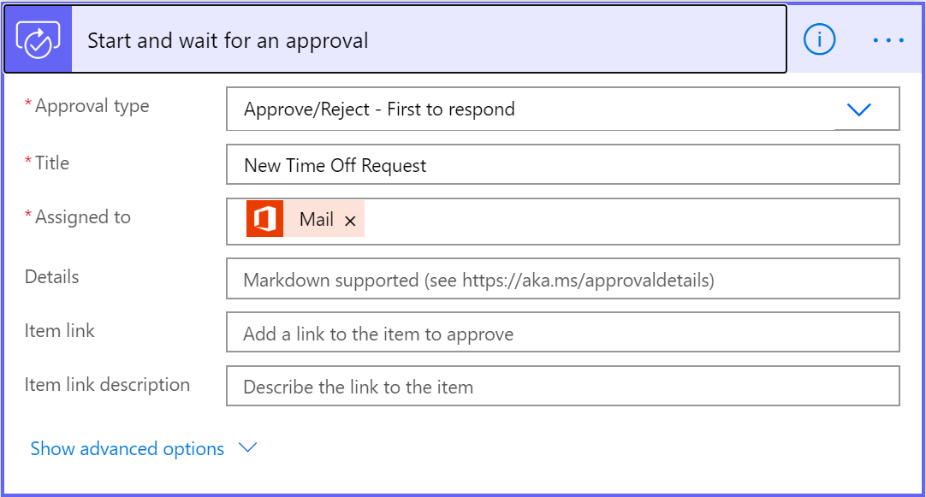

# Power Automate Flow deployment

## Import Package

1. Open an internet browser and go to <https://flow.microsoft.com>
2. Sign in with the credentials provided by the trainer:



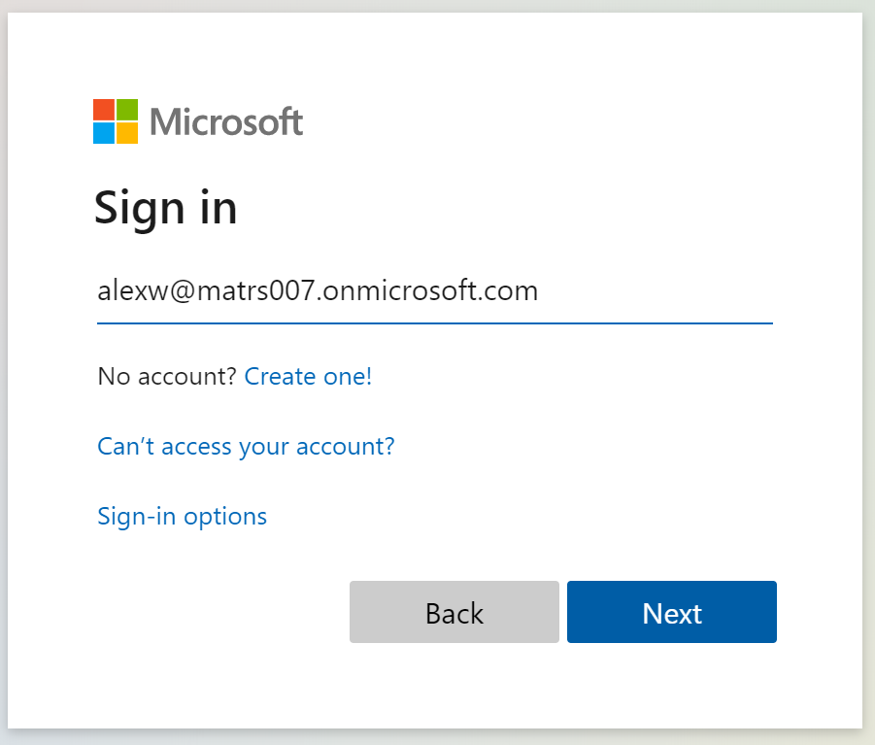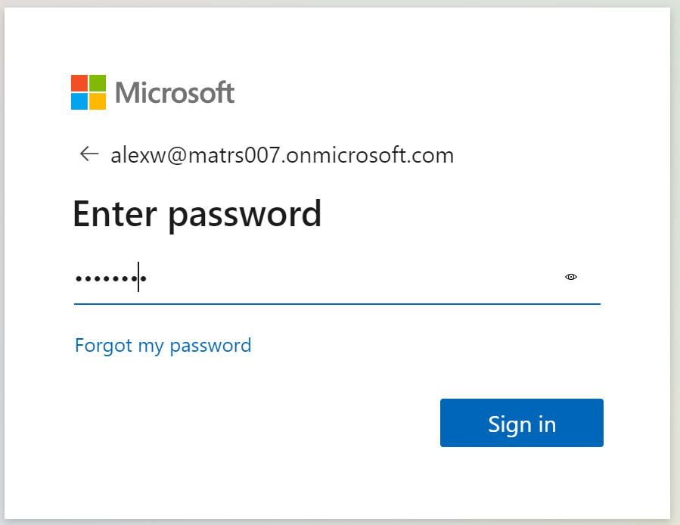

1. Once Authenticated. Go to “My flows” on the left menu bar:

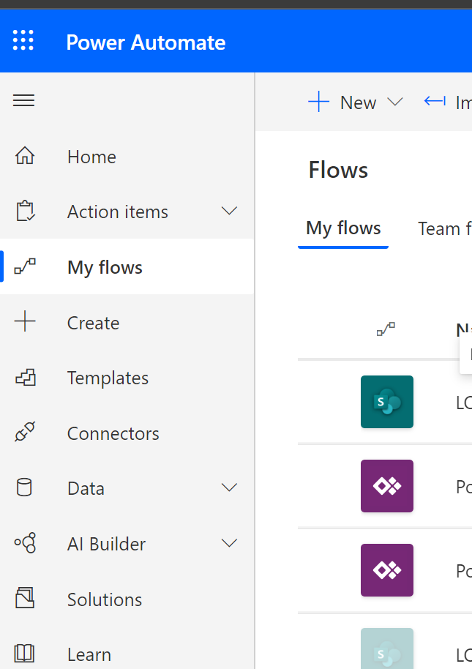

1. Next click on Import on the menu bar:

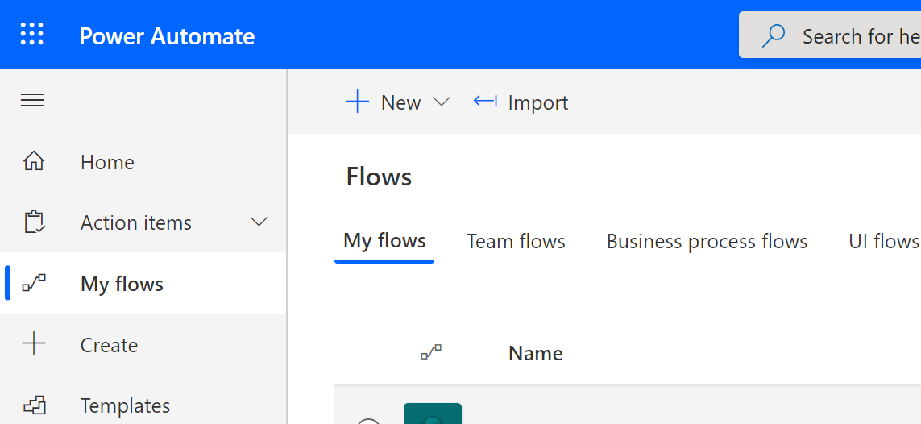

1. On the next screen select the upload button and browse for the Power Automate Sample ZIP file.

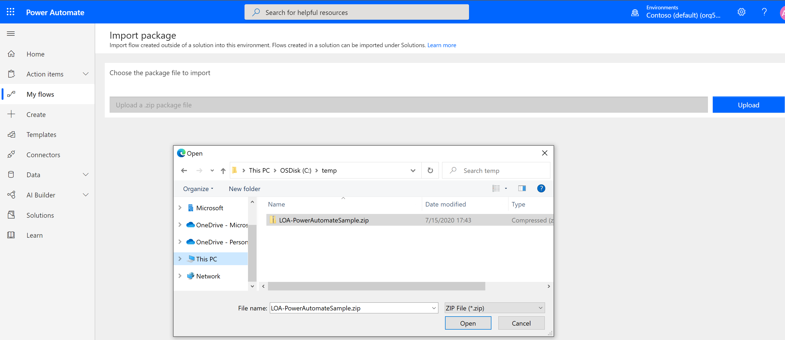

1. Click open and wait for the Power Automate definition to load. The upload will be disabled while is working:

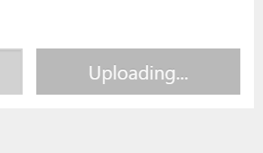

1. Once the Import package page has finished loading, change each of the connectors with red warnings. For each of them:
   1. Open the link “Select during import”:

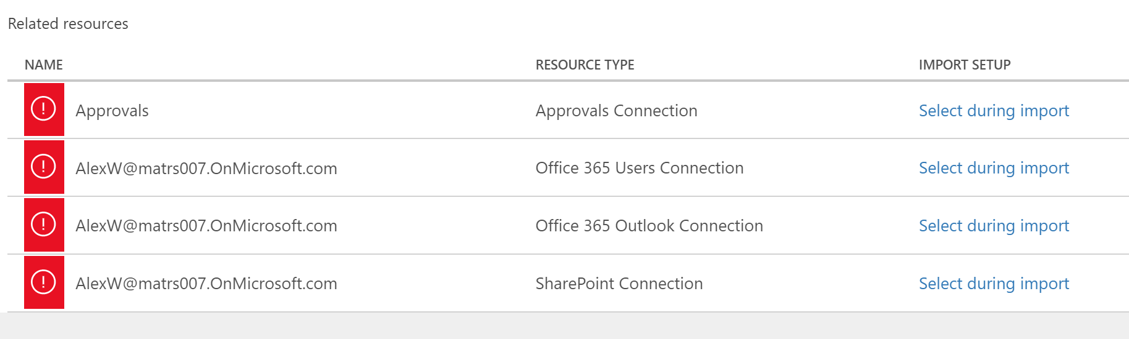

* 1. On the Import Setup panel that appears, select “+Create new”, a new tab will show up in the browser:

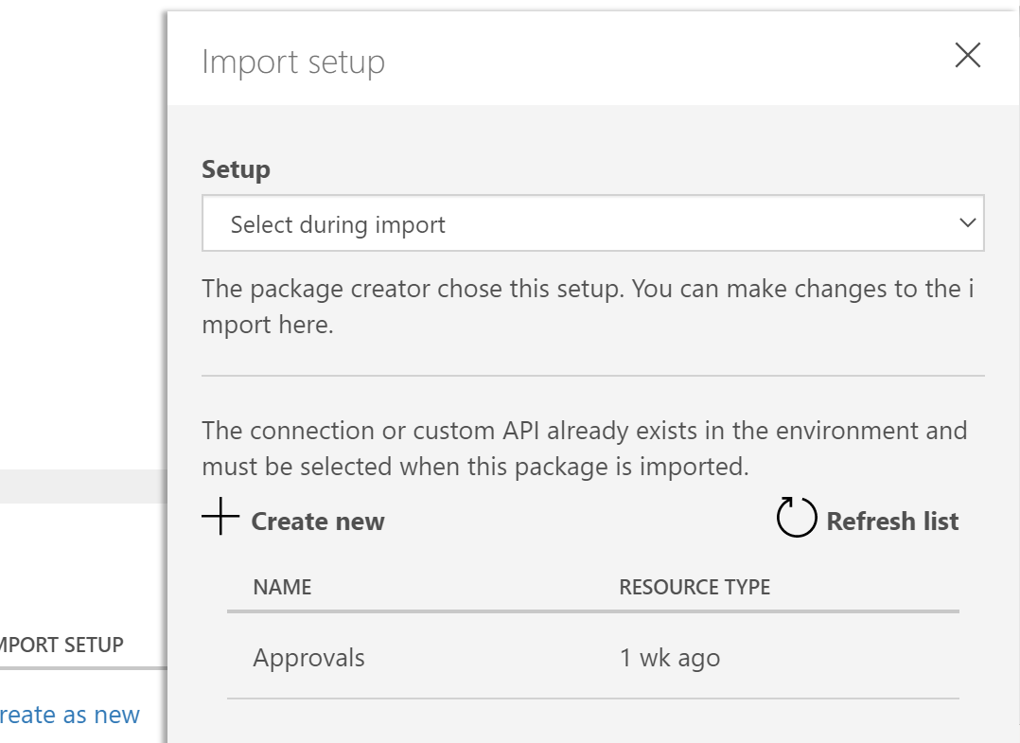

* 1. Select “New Connection” and look for the connector you are fixing. In this case “Approvals” and click the Plus Sign:

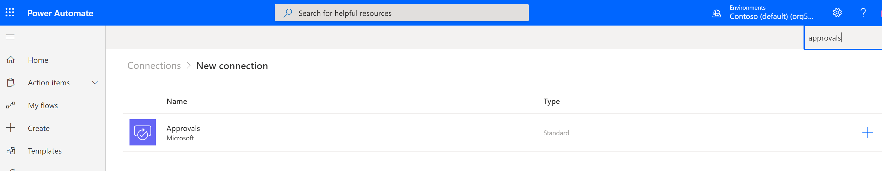

* 1. In the pop-up select “Create”.

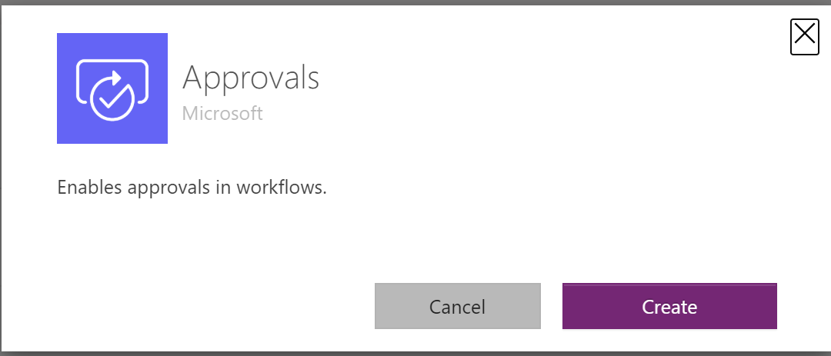

* 1. Go back to the other tab in the browser and refresh the connections list, select the one you just created and hit “Save”

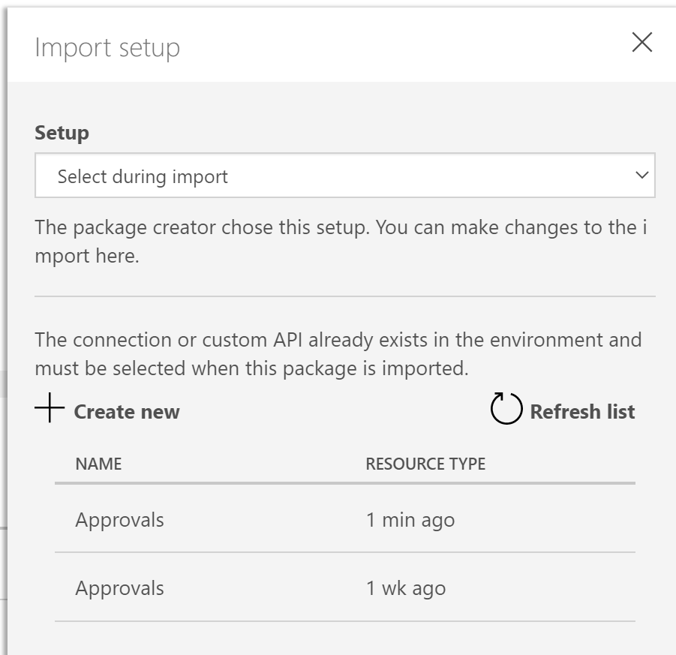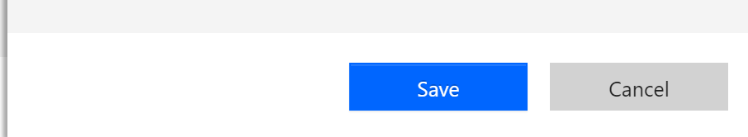

1. Repeat from steps **a.** to **e.** for all the connectors until the Import Button is enabled, then hit import:

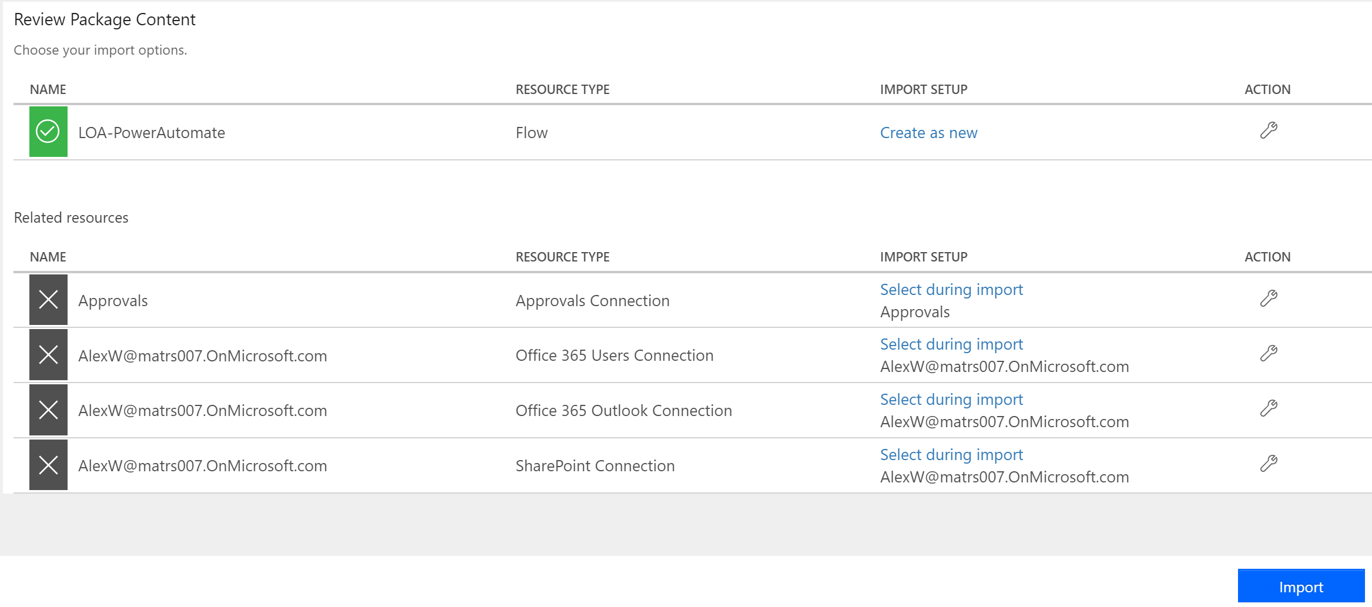

## Customize Power Automate flow

As the flow was created in a different tenant and/or for a different list, we need to edit it in order to make it work in the new environment.

1. Expand the **trigger** and select the corresponding site and the list.
   1. Site: https://*<TENANT NAME>*.sharepoint.com/sites/ContosoElectronics*<n>*
   2. A screenshot of a social media post

      Description automatically generatedList Name: Time Off Requests - New
2. Do the same for all the SharePoint Actions you find in the workflow that requires a Site and a List.
3. Expand all the actions and if you find a warning sign select the connection you created during import.

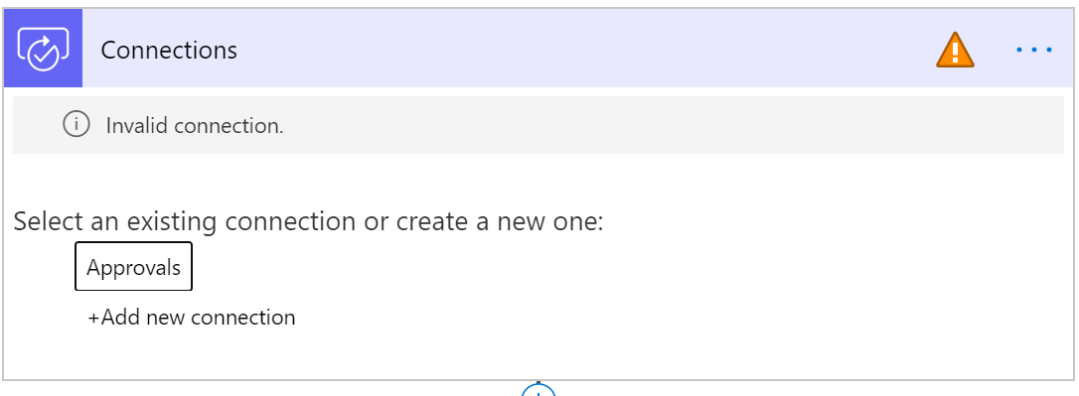

Once you finish, save the flow, and check any errors popping up when saving.

The flow now is ready to test.